**RAJSHAHI UNIVERSITY OF ENGINEERING AND TECHNOLOGY**

**Course No:** CSE 3110

**Course Title:** Sessional Based on CSE 3109

**Problem No:** 04

**Problem Name:** Write a program to input a string and reverse every word of the string.

**Submitted To:**

Sadia Zaman Mishu

Assistant Professor

Computer Science and Engineering

Rajshahi University of Engineering and Technology

**Submitted By:**

Name : Md. Fakhrul Islam

Roll: 1803071

Session: 2018-19

Department : Computer Science and Engineering

Rajshahi University of Engineering and Technology

**Problem No:** 04

**Problem Name:** Write a program to input a string and reverse every word of the string.

**Description:**

A one-dimensional array is an ordered list of elements. Basically, string is the array of character. Consecutive memory location is occupied by the array. By using DUP instructions, an array is initialized by a common value. There are mainly three addressing modes which are register mode, immediate mode and direct mode. Besides, there are four additional addressing modes. And they are Register Indirect, Based, Indexed, Based Indexed. In this problem, register indirect mode is used. A (‘$’) sign is used to detect the finishing of the string. 20h hexadecimal value is used for space. For addressing source index is used. As the array is a byte array, the value of source index is increasing by 1.

**CODE:**

|  |  |
| --- | --- |
| .MODEL SMALL  .STACK 100H  .DATA  MSG DB 50 DUP('?')  .CODE  MAIN PROC  MOV AX,@DATA  MOV DS,AX  MOV BX,0  LEA SI,MSG  MOV AH,1  INT 21H  INPUT:  INC BX  CMP AL,0DH  JE OUTPUT  MOV MSG[SI],AL  ADD SI,1  INT 21H  JMP INPUT  OUTPUT:  MOV MSG[SI],'$'  MOV AH,2  MOV DL,0AH  INT 21H  MOV DL,0DH  INT 21H  LEA SI,MSG  MOV BX,0  JMP OUTPUT1 | OUTPUT1:  CMP [SI],20H  JE PRINT  CMP [SI],24H  JE PRINT  INC BX  INC SI  JMP OUTPUT1  PRINT:  MOV CX,BX  LEA DI,SI  DEC DI  PRINT1:  MOV AH,2  MOV DL,[DI]  INT 21H  DEC DI  LOOP PRINT1  CMP [SI],24H  JE EXIT  MOV BX,0  INC SI  MOV AH,2  MOV DL,20H  INT 21H  JMP OUTPUT1  EXIT:  MOV AH,4CH  INT 21H  MAIN ENDP  END MAIN |

**OUTPUT:**

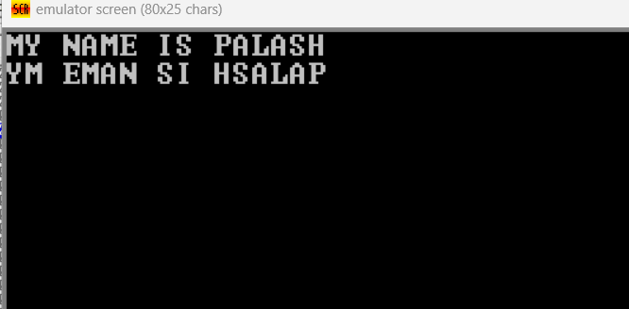

**Conclusion:**

Without using $ sign, the program will display a wrong answer. And at a same time, it will create an infinite loop. To avoid the infinite loop and detect the finishing of the string, $ sign is used whose hexadecimal value is 24h. To address the array source index (SI) is used. As it is a byte array, source index is increasing by one. Also, to display the output destination index is used.